Name _____________________
Giver Memoir Writing

What is memoir writing?

Follow along in the passage. Record what makes this a good memoir.

“It was very startling; but he was not at all frightened, now. He was filled with energy, and he breathed again, feeling the sharp intake of frigid air. Now, too, he could feel cold air swirling around his entire body. He felt it blow against his hands where they lay at his sides, and over his back.

The touch of the man's hands seemed to have disappeared.

Now he became aware of an entirely new sensation: pinpricks? No, because they were soft and without pain. Tiny, cold, featherlike feelings peppered his body and face. He put out his tongue again, and caught one of the dots of cold upon it. It disappeared from his awareness instantly; but he caught another, and another. The sensation made him smile.”
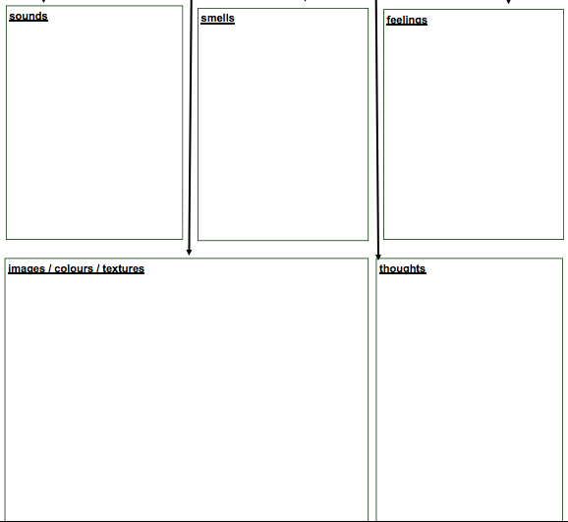
Imagine that you are Jonas watching the three videos. Make notes of what you see, think, hear, smell and feel.

Working with your group, you will create a memoir-like description of one video from Jonas’ point of view.

Requirements for memoir:

Minimum of three paragraphs

Written from Jonas’ point of view
(uses ‘I’)
Descriptive language: one from each category
Sounds
Smells
Feelings
Images/colors/textures
Thoughts
Picture derived from memoir
Other descriptive language and details

_________________________________________________________________________________________________________________________________________________________________________________________________________________________________________________________________________________________________________________________________________________________________________________________________________________________________________________________________________________________________________________________________________________________________________________________________________________________________________________________________________________________________________________________________________________________________________________________________________________________________________________________________________________________________________________________________________________________________________________________________________________________________________________________________________________________________________________________________________________________________________________________________________________________________________________________________________________________________________________________________________________________________________________________________________________________________________________________________________________________________________________________________________________________________________________________________________________________________________________________________________________________________________________________________________________________________________________________________________________________________________________________________________________________________________________________________________________________________________________________________________________________________________________________________________________________________________________________________________________________________________________________________________________________________________________________________________________________________________________________________________________________________________________________________________________________________________________________________________________________________________________________________________

